**Experiment No.8 Date:23/11/2021**

**Power Factor Improvement**

**Objective:**

* To study the effect on inductive load and power factor
* To improve the power factor and understand the advantages

**Circuit:**

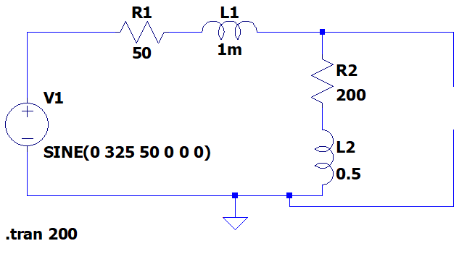

**Simulation Tool:**

LTSpice – transient analysis

**Observation**

**Source Voltage: vs(t) =325V, Vsrms= 230V**

|  |  |  |  |  |  |  |  |  |
| --- | --- | --- | --- | --- | --- | --- | --- | --- |
| Load | Load Impedance  ( | Line Current (Irms) | Load Terminal Voltage (Vrms) | Phase Angle Measured  ( | Power Factor | Real Power P(W) | Reactive Power Q(VAR) | Line Losses (W) |
| (R+jXL)  200+j157 | 254.26 | 0.777A | 197.7V | 38.5 | 0.782(lag) | 120.88 | 94.5 | 30.3 |
| R+jXL with C1  200+j157  c = 4.51µF | 335.18 | 0.65A | 198.78V | 18.9 | 0.95(lag) | 122.81 | 40.16 | 21.15 |
| R+jXL with C2  200+j157  c = 5µF | 359.99 | 0.64A | 199.35V | 16.26 | 0.96(lag) | 122.94 | 34.09 | 20.24 |
| R+jXL with C3  200+j157  c = 4.51µF | 370.20 | 0.62A | 199.49A | 7.69 | 0.99(lead) | 122.67 | -15.80 | 19.07 |

Observe the results and comment on the changes in the following parameters:

1. Power Factor
2. Line losses
3. Terminal Voltage
4. Real Power
5. Reactive Power

Verify with theoretical calculation for load 1 and load 2 in the table

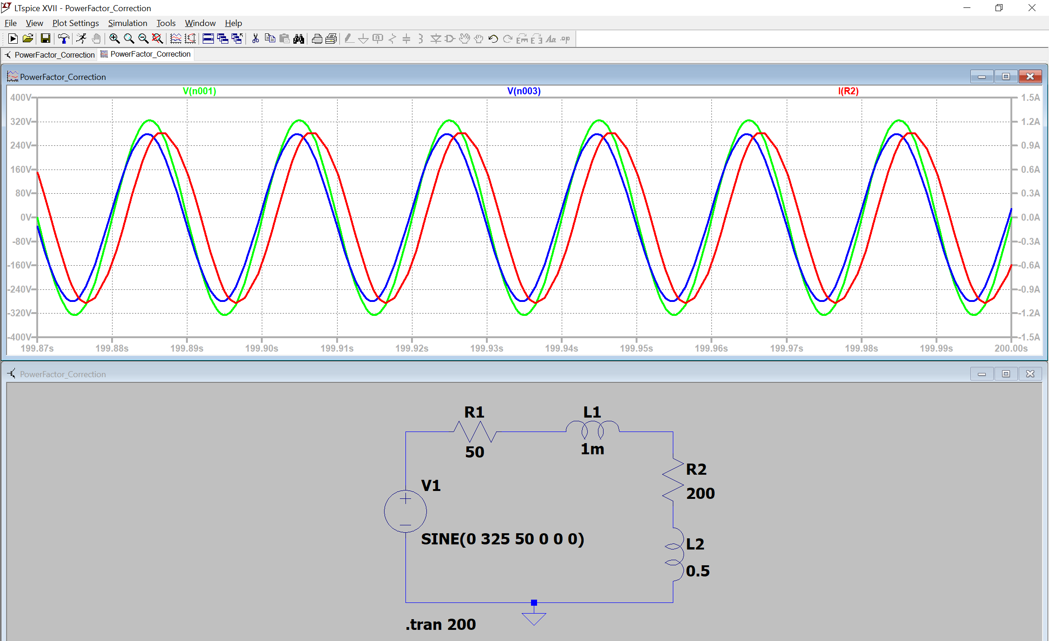

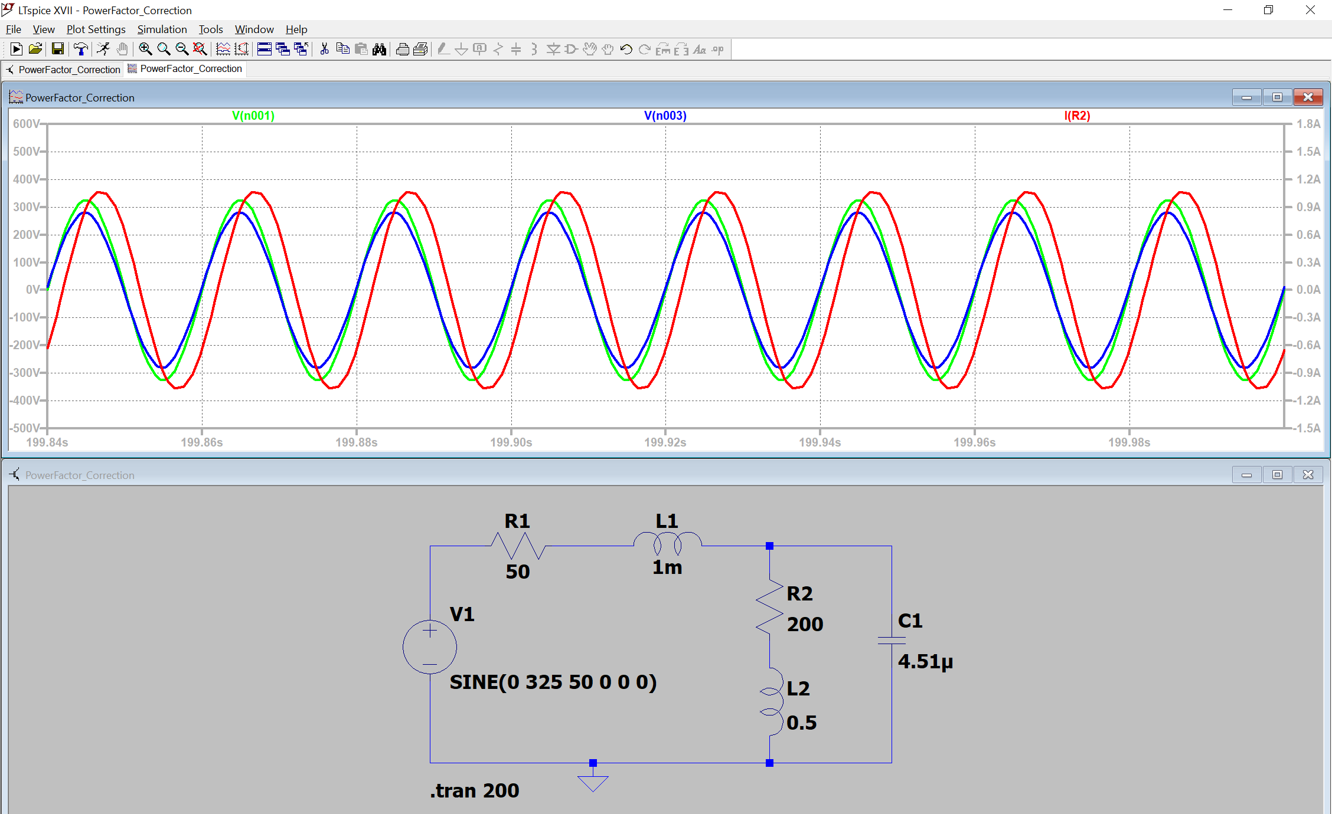

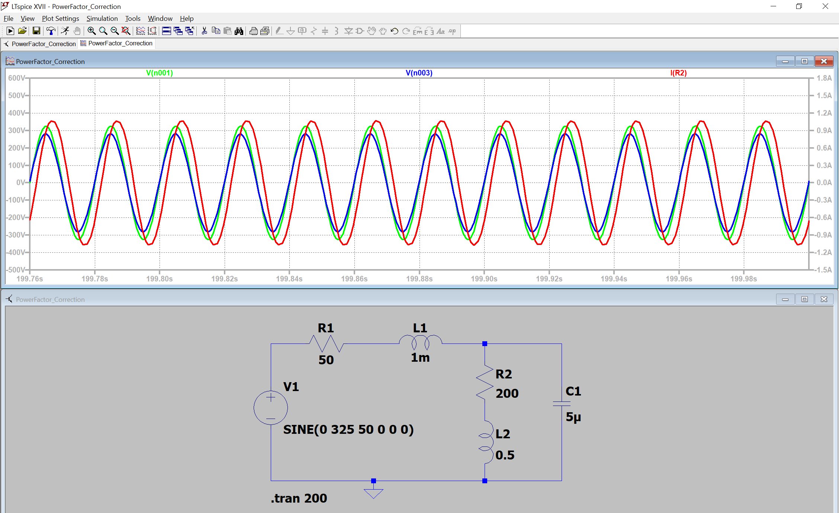

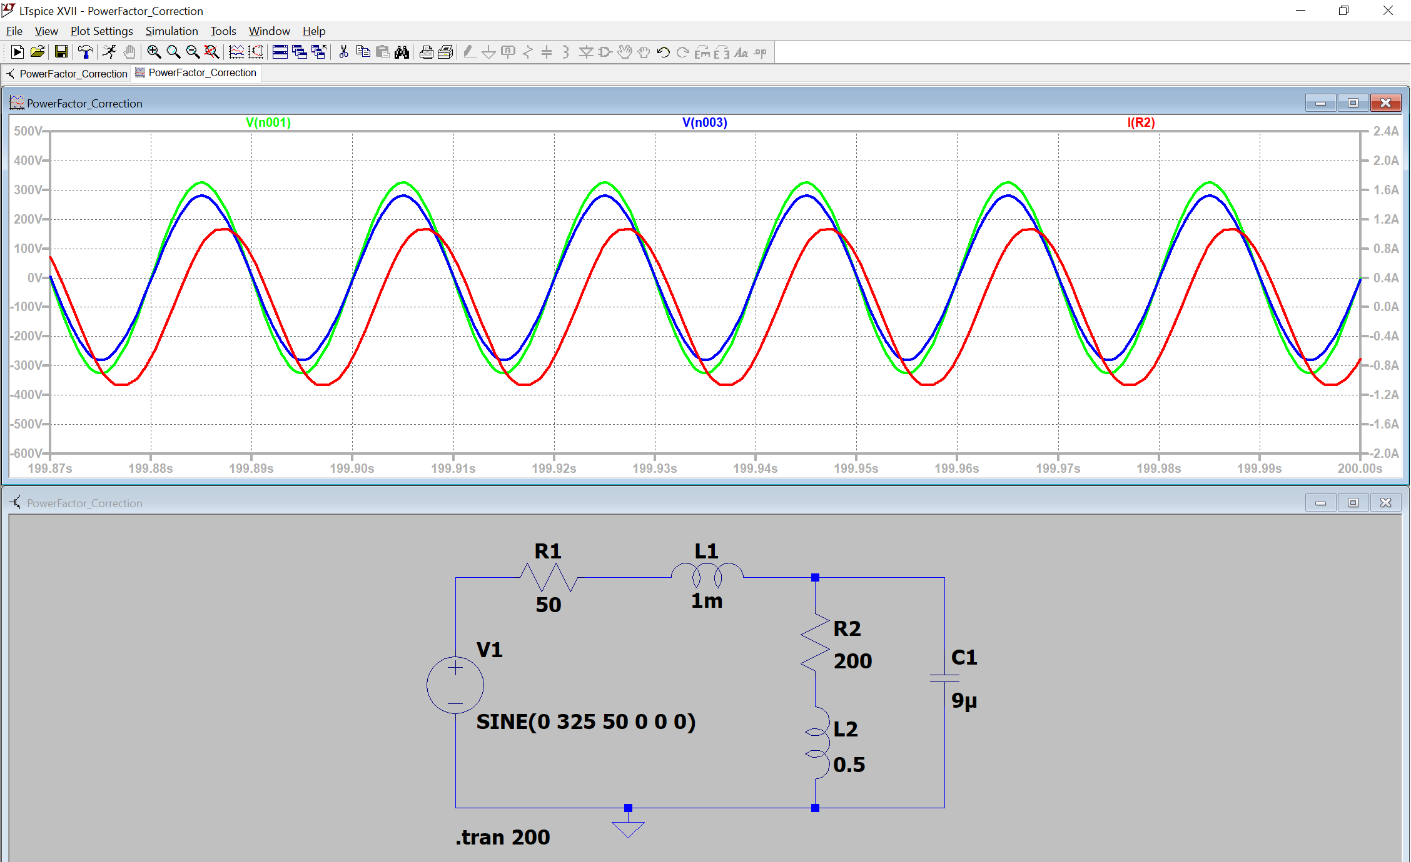

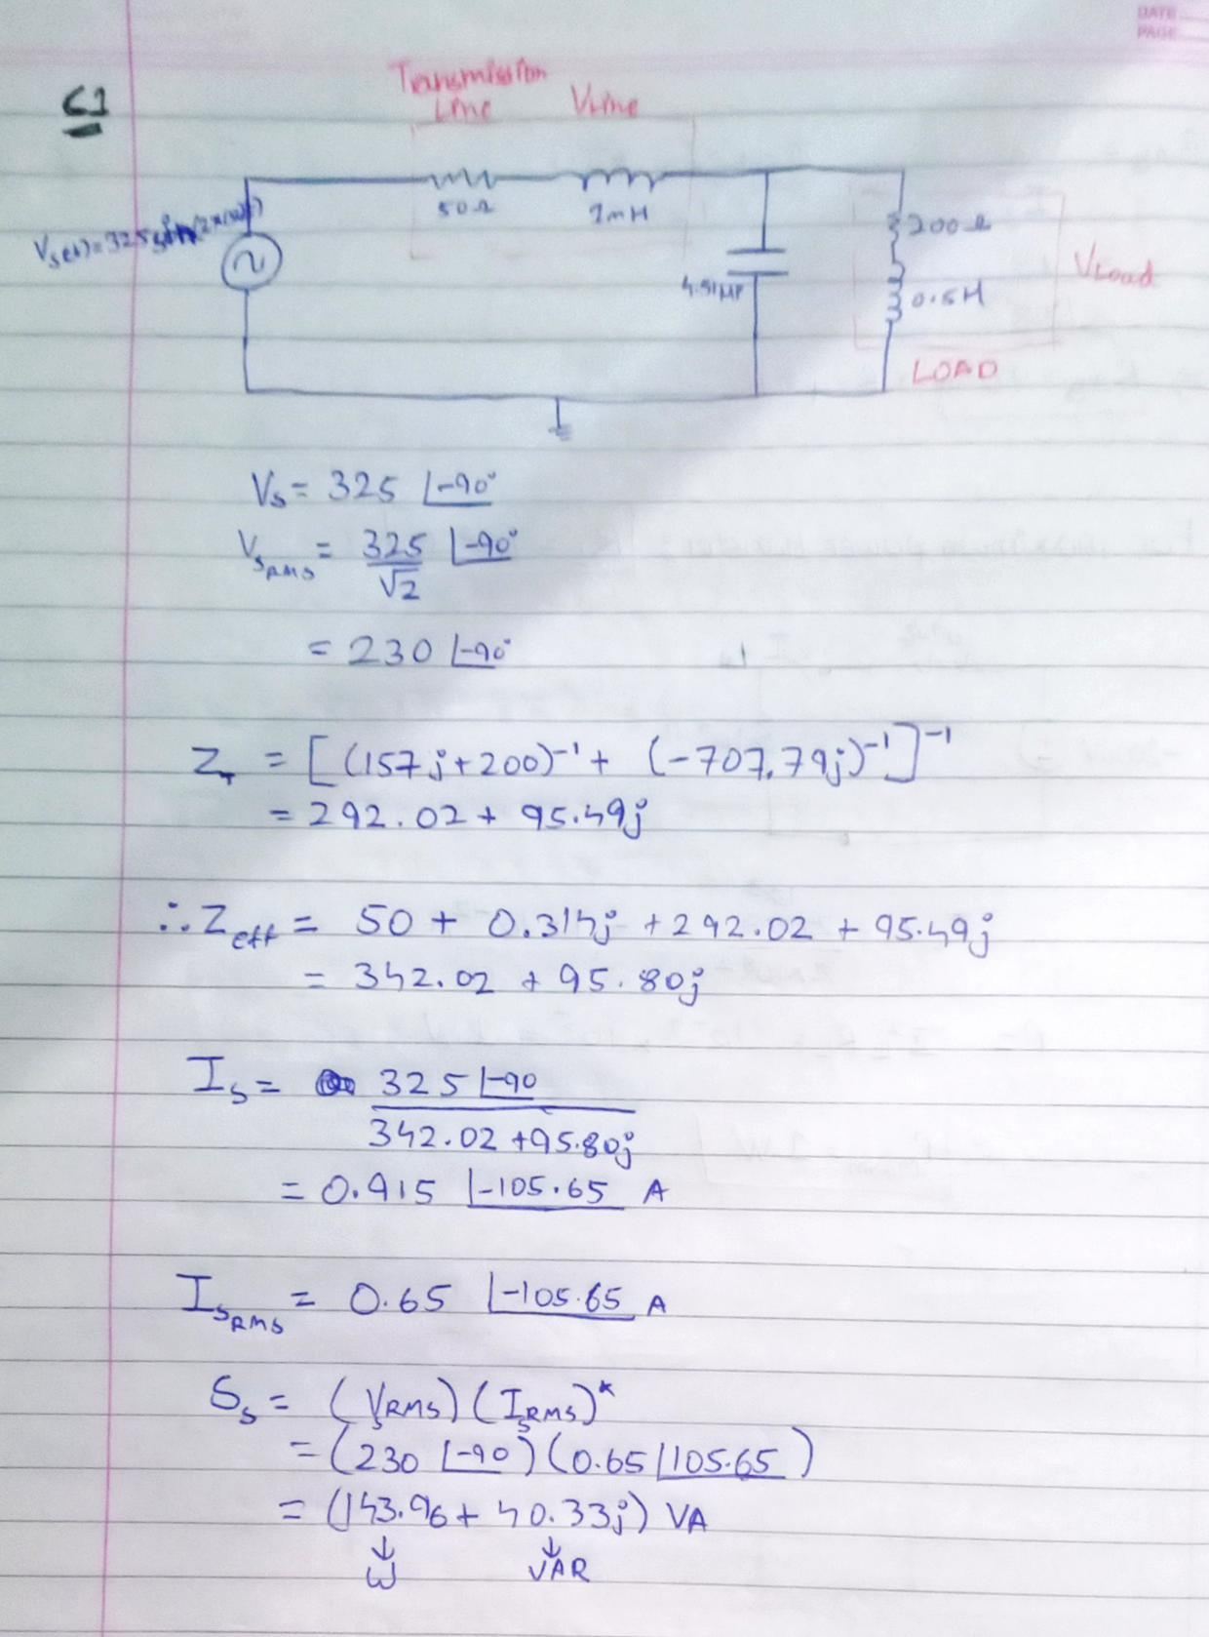**Calculations:**

